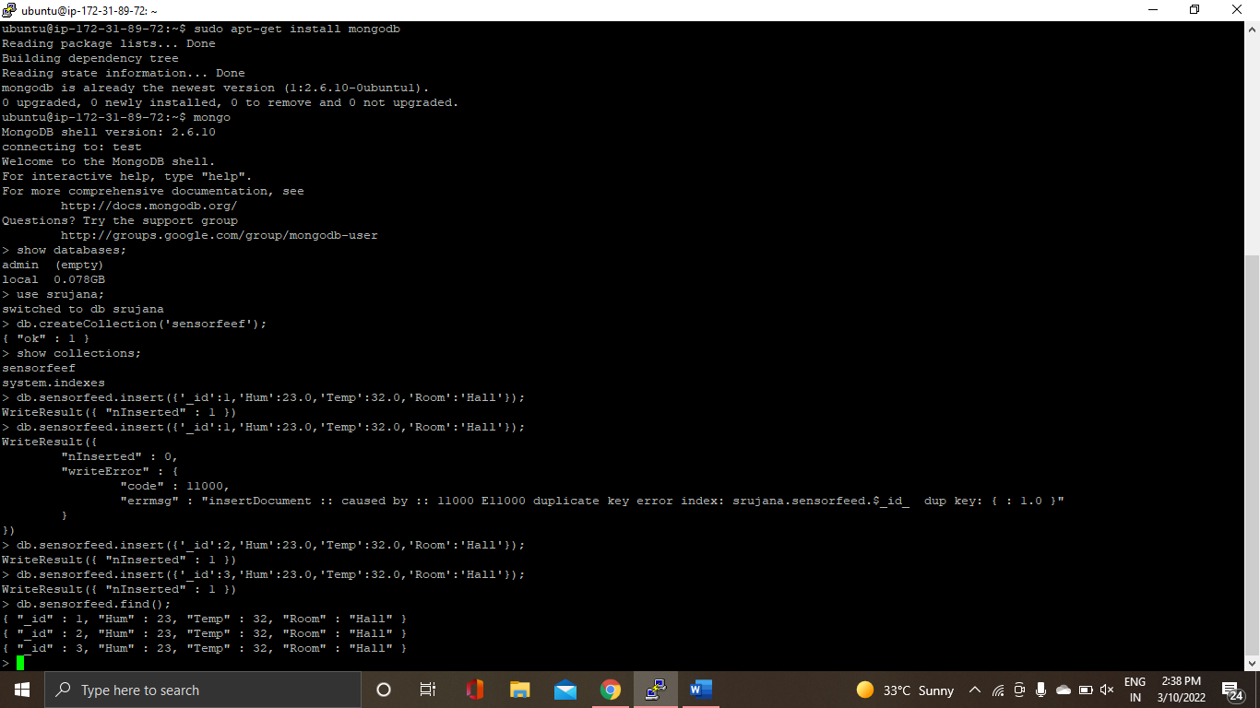



from pymongo import MongoClient

# CREATE A CONNECTION FROM THIS SCRIPT TO DATABASE

db=MongoClient('localhost',27017)

#CREATE OR SELECT DATABASE

d=db['srujana']

# SELECT COLLECTION

c=d['sensorfeed']

id=int(raw_input('Enter primarybkey value: '))

Hum=int(raw_input('Enter humidity value: '))

Temp=int(raw_input('Enter temperature value: '))

# CREATE A DOCUMENT

k={'_id':id,'Hum':Hum,'Temp':temp}

# INSERT THE DOCUMENT

c.insert_one(k)

# READING THE DOCUMENT

for i in c.find():

print(i)

